Kubernetes Task-04
- Deploy an application using a Deployment with 3 replicas and a rolling update strategy.
- Configure a Deployment with a Recreate strategy and observe the downtime.
- Update an existing Deployment and perform a rollback to the previous version.
- Modify a Deployment to add resource requests and limits for CPU and memory.
- Create a Deployment with MaxSurge and MaxUnavailable configurations.
- Set up a Deployment with a custom revision history limit.
- Pause a Deployment during an update, and then resume it.
- Create a pod using resource requests for memory and CPU, and observe how the scheduler assigns it to a node.

Task 1 — Deployment with 3 Replicas and Rolling Update

1. Objective
Create a Kubernetes Deployment that:
- Runs 3 replicas of an Nginx application.
- Uses the RollingUpdate strategy.
- Allows Kubernetes to gradually replace old Pods with new Pods.
- Demonstrates how Kubernetes performs an application update with minimal/no downtime.

2. Architecture
Kubernetes Cluster
|
v
+-------------+
| Deployment |
| nginx-deploy|
+-------------+
|
replicas: 3
|
+-------------+-------------+
| | |
v v v
+------+ +------+ +------+
| Pod 1| | Pod 2| | Pod 3|
| nginx| | nginx| | nginx|
+------+ +------+ +------+

During Rolling Update

Deployment
|
+-----------+-----------+
| |
Old ReplicaSet New ReplicaSet
| |
Old Pods New Pods
nginx:v1 nginx:v2
| |
+----------+------------+
|
Gradually replace
old with new

Flow explanation
- We create a Deployment.
- The Deployment creates a ReplicaSet.
- The ReplicaSet creates 3 Nginx Pods.
- All 3 Pods initially run the same application version.
- When we update the Deployment—for example, from nginx:1.27 to nginx:1.28—Kubernetes creates a new ReplicaSet.
- The RollingUpdate strategy gradually creates new Pods and removes old Pods.
- Kubernetes continues this process until all 3 Pods are running the new version.

3. Implementation

Step 3.1 — Check your cluster
Run this on your k8s-master:
kubectl get nodes
Expected:
NAME STATUS ROLES AGE VERSION
k8s-master Ready control-plane ... v1.37.0
k8s-worker1 Ready <none> ... v1.37.0
k8s-worker2 Ready <none> ... v1.37.0
Your node names may differ.

Why?
The Kubernetes scheduler needs available worker nodes to place the Pods.

Step 3.2 — Check existing Deployments
kubectl get deployments
If you have existing Deployments, that's okay.
For this task, we will create a separate Deployment called:
nginx-deployment

4. Create the Deployment YAML
Create a file:
nano nginx-deployment.yaml
Add:
apiVersion: apps/v1
kind: Deployment

metadata:
name: nginx-deployment

spec:
replicas: 3

strategy:
type: RollingUpdate
rollingUpdate:
maxSurge: 1
maxUnavailable: 0

selector:
matchLabels:
app: nginx

template:
metadata:
labels:
app: nginx

spec:
containers:
- name: nginx
image: nginx:1.27
ports:
- containerPort: 80
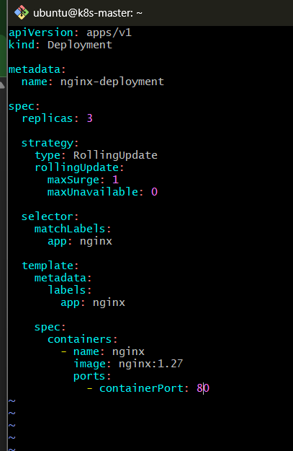
Save:
Ctrl + O
Enter
Ctrl + X

5. Understand the Important Parts

replicas: 3
replicas: 3
Means Kubernetes should maintain:
3 Pods
If one Pod crashes, the Deployment/ReplicaSet will create another Pod to maintain the desired count.

RollingUpdate
strategy:
type: RollingUpdate
This tells Kubernetes:
Don't remove all old Pods at once. Gradually replace them with new Pods.

maxSurge: 1
maxSurge: 1
During an update, Kubernetes can temporarily create 1 additional Pod above the desired replica count.
Normally:
Desired = 3
During update:
Maximum = 4 Pods
For example:
Old Pods:
Pod-1
Pod-2
Pod-3

During update:

Pod-1 old
Pod-2 old
Pod-3 old
Pod-4 new
Then an old Pod can be removed.

maxUnavailable: 0
maxUnavailable: 0
This means:
Don't intentionally make any of the desired 3 Pods unavailable during the rolling update.
So Kubernetes tries to keep all 3 replicas available while replacing them.

6. Apply the Deployment
Run:
kubectl apply -f nginx-deployment.yaml
Expected:
deployment.apps/nginx-deployment created

7. Check the Deployment
kubectl get deployment
Expected:
NAME READY UP-TO-DATE AVAILABLE AGE
nginx-deployment 3/3 3 3 ...
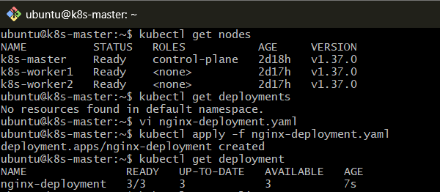

Meaning
READY
3/3
Three Pods are ready.
UP-TO-DATE
3
Three Pods are running the latest Deployment configuration.
AVAILABLE
3
Three Pods are available to serve the application.

8. Check the ReplicaSet
Run:
kubectl get replicasets
Expected something similar to:
NAME DESIRED CURRENT READY AGE
nginx-deployment-xxxxxxxxxx 3 3 3 ...
Remember the relationship:
Deployment
|
v
ReplicaSet
|
v
3 Pods

9. Check the Pods
kubectl get pods -o wide
You should see 3 Nginx Pods.
Example:
NAME READY STATUS IP NODE
nginx-deployment-xxxxxxxxxx-abc12 1/1 Running 192.168.x.x k8s-worker1
nginx-deployment-xxxxxxxxxx-def34 1/1 Running 192.168.x.x k8s-worker2
nginx-deployment-xxxxxxxxxx-ghi56 1/1 Running 192.168.x.x k8s-worker1
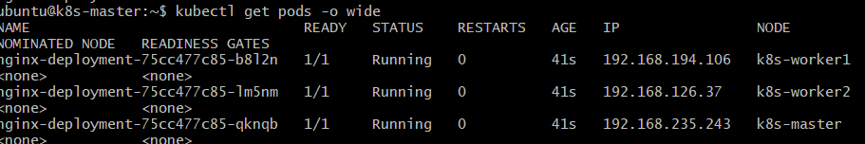
The actual Pod names and IP addresses will be different.

10. Verify the Deployment Strategy
Run:
kubectl describe deployment nginx-deployment
Look for:
StrategyType: RollingUpdate
RollingUpdateStrategy: 0 max unavailable, 1 max surge
This confirms our configuration.
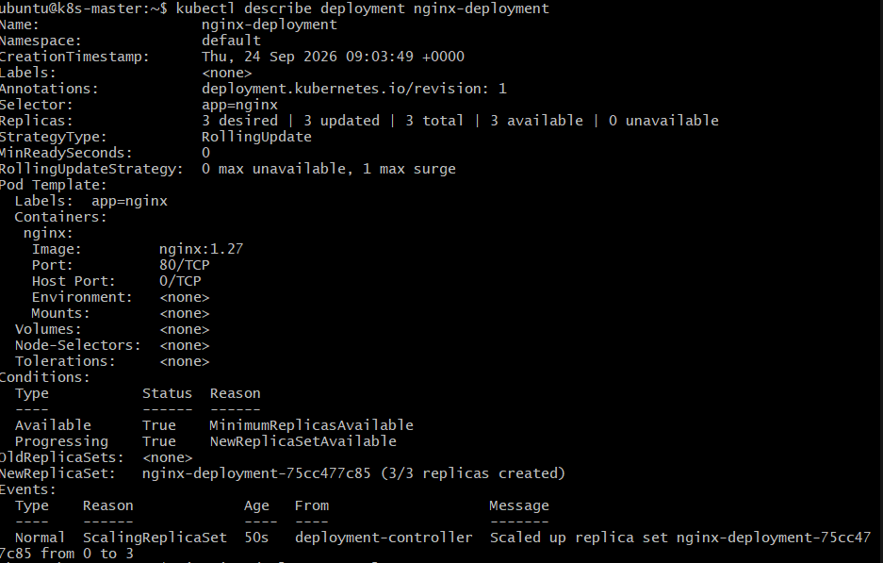

11. Perform a Rolling Update
Now we'll demonstrate why we selected RollingUpdate.
Change:
image: nginx:1.27
to:
image: nginx:1.28
So your container section becomes:
containers:
- name: nginx
image: nginx:1.28
ports:
- containerPort: 80
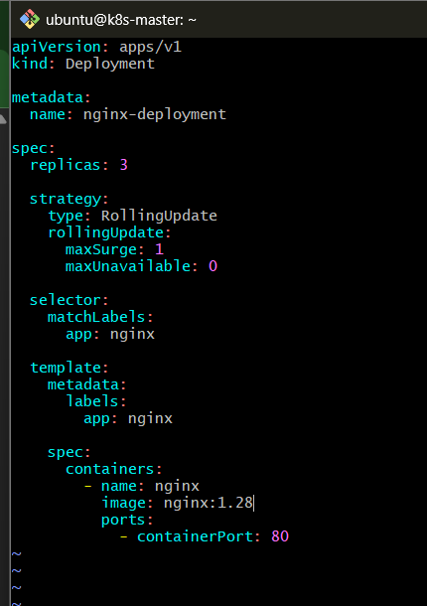
Save the file.
Then run:
kubectl apply -f nginx-deployment.yaml
Expected:
deployment.apps/nginx-deployment configured

12. Watch the Rolling Update
Immediately run:
kubectl rollout status deployment/nginx-deployment
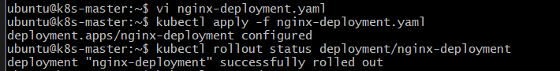
You should eventually see:
deployment "nginx-deployment" successfully rolled out
You can also watch Pods:
kubectl get pods -w
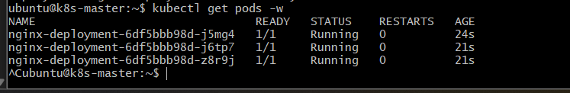
You may see old Pods being terminated and new Pods being created.
Press:
Ctrl + C
to stop watching.

13. Check Rollout History
Run:
kubectl rollout history deployment/nginx-deployment
You should see revisions similar to:
deployment.apps/nginx-deployment
REVISION CHANGE-CAUSE
1 <none>
2 <none>
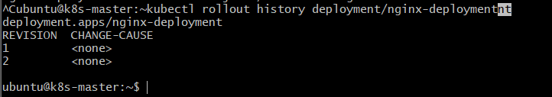
Why?
Because we performed:
Revision 1
nginx:1.27
|
| Rolling Update
v
Revision 2
nginx:1.28

14. Final Validation
Run these commands:

Deployment
kubectl get deployment nginx-deployment
Expected:
3/3
3
3

ReplicaSet
kubectl get rs

Pods
kubectl get pods -o wide

Image version
kubectl describe deployment nginx-deployment | grep -i image
Expected:
Image: nginx:1.28
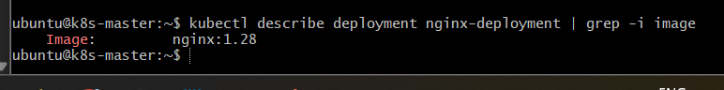

Rollout status
kubectl rollout status deployment/nginx-deployment
Expected:
deployment "nginx-deployment" successfully rolled out

15. Final Architecture After Update
Deployment
nginx-deployment
|
replicas = 3
|
RollingUpdate
|
+----------+----------+
| |
Old ReplicaSet New ReplicaSet
nginx:1.27 nginx:1.28
| |
Old Pods New Pods
| |
+----------+----------+
|
Final State
|
+---------+---------+
| | |
v v v
Pod-1 Pod-2 Pod-3
nginx:1.28 nginx:1.28 nginx:1.28
The important point is that the Deployment manages the ReplicaSet, and the ReplicaSet manages the Pods.

16. Expected Outcome
After completing Task 1:
- A Deployment named nginx-deployment exists.
- It maintains 3 replicas.
- The Deployment uses RollingUpdate.
- maxSurge is configured as 1.
- maxUnavailable is configured as 0.
- The application was successfully updated from nginx:1.27 to nginx:1.28.
- Kubernetes created a new ReplicaSet and gradually replaced the old Pods.
- The final state has 3 running Pods using nginx:1.28.

Task 2 — Deployment with Recreate Strategy

1. Objective
Configure a Kubernetes Deployment using the Recreate strategy and observe what happens to the existing Pods during an application update.
The key difference from Task 1:
- RollingUpdate: old and new Pods can temporarily coexist.
- Recreate: Kubernetes terminates all existing Pods first, then creates the new Pods.
2. Architecture

Before update
Deployment
nginx-recreate
|
replicas: 3
|
+-----------+-----------+
| | |
v v v
Pod-1 Pod-2 Pod-3
nginx:1.27 nginx:1.27 nginx:1.27

During Recreate update
Deployment
|
v
Delete existing Pods
|
+---------+---------+
| | |
v v v
Pod-1 Pod-2 Pod-3
DELETED DELETED DELETED
|
No Pods running
|
v
Create new Pods
|
+------------+------------+
| | |
v v v
Pod-1 Pod-2 Pod-3
nginx:1.28 nginx:1.28 nginx:1.28

Flow explanation
- The Deployment initially runs 3 Pods.
- We change the application image from nginx:1.27 to nginx:1.28.
- Because the strategy is Recreate, Kubernetes terminates the existing Pods.
- For a short period, zero application Pods are running.
- Kubernetes then creates 3 new Pods.
- Once the new Pods become Ready, the Deployment returns to its desired state of 3 replicas.
This temporary period with no application Pods is the downtime we want to observe.

3. Implementation

Step 3.1 — Create a new Deployment
We will create a new Deployment so we don't modify the Task 1 Deployment.
Create:
nano nginx-recreate.yaml
Add:
apiVersion: apps/v1
kind: Deployment

metadata:
name: nginx-recreate

spec:
replicas: 3

strategy:
type: Recreate

selector:
matchLabels:
app: nginx-recreate

template:
metadata:
labels:
app: nginx-recreate

spec:
containers:
- name: nginx
image: nginx:1.27
ports:
- containerPort: 80
Save:
Ctrl + O
Enter
Ctrl + X
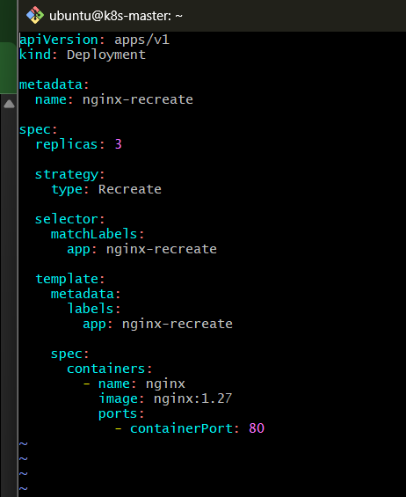

4. Understand the Important Configuration
The important part is:
strategy:
type: Recreate
Unlike Task 1, there is no:
rollingUpdate:
maxSurge: 1
maxUnavailable: 0
because those settings apply to the RollingUpdate strategy.
With Recreate, Kubernetes follows:
Delete old Pods
↓
Create new Pods

5. Create the Deployment
Run:
kubectl apply -f nginx-recreate.yaml
Expected:
deployment.apps/nginx-recreate created

6. Verify the Deployment
Run:
kubectl get deployment nginx-recreate
Expected:
NAME READY UP-TO-DATE AVAILABLE AGE
nginx-recreate 3/3 3 3 ...
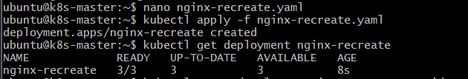

7. Check the Pods
Run:
kubectl get pods -l app=nginx-recreate -o wide
You should see 3 Pods:
NAME READY STATUS NODE
nginx-recreate-xxxxxxxxxx-abc 1/1 Running k8s-worker1
nginx-recreate-xxxxxxxxxx-def 1/1 Running k8s-worker2
nginx-recreate-xxxxxxxxxx-ghi 1/1 Running k8s-worker1
Your Pod names will be different.
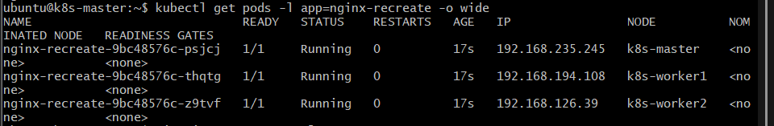

8. Observe the Recreate Strategy
Now change:
image: nginx:1.27
to:
image: nginx:1.28
Your YAML should now contain:
spec:
replicas: 3

strategy:
type: Recreate

selector:
matchLabels:
app: nginx-recreate

template:
metadata:
labels:
app: nginx-recreate

spec:
containers:
- name: nginx
image: nginx:1.28
ports:
- containerPort: 80
Save the file.
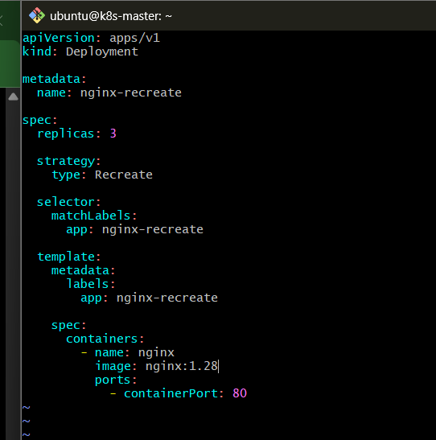

9. Watch the Pods During the Update
This is the important part of this task.
First start watching:
kubectl get pods -l app=nginx-recreate -w
Keep this terminal running.
Then, from another terminal on k8s-master, run:
kubectl apply -f nginx-recreate.yaml
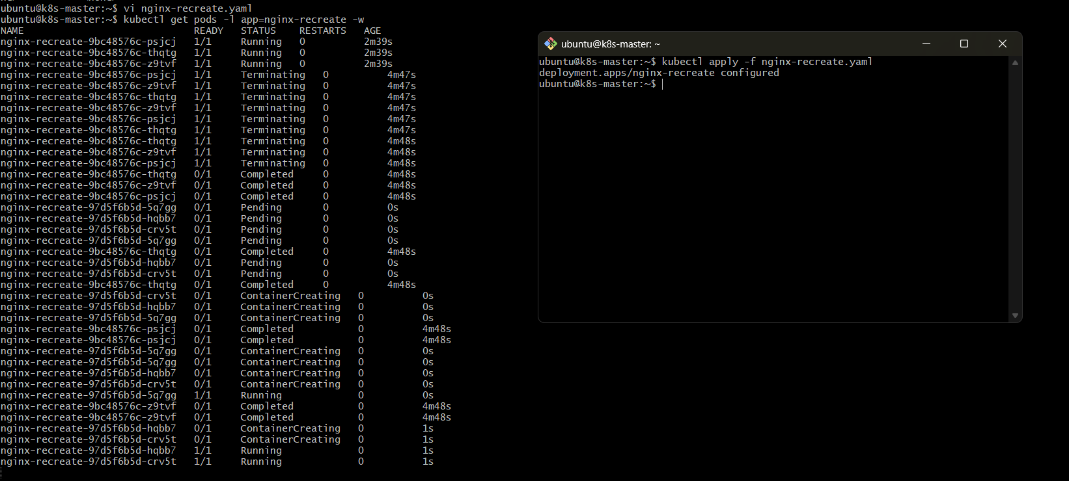
Watch what happens.
You should observe something similar to:
nginx-recreate-xxxxx 1/1 Running
nginx-recreate-yyyyy 1/1 Running
nginx-recreate-zzzzz 1/1 Running
Then the old Pods disappear:
nginx-recreate-xxxxx Terminating
nginx-recreate-yyyyy Terminating
nginx-recreate-zzzzz Terminating
Eventually:
No resources found
or there may briefly be no Pods displayed.
Then new Pods appear:
nginx-recreate-aaaaa 0/1 ContainerCreating
nginx-recreate-bbbbb 0/1 ContainerCreating
nginx-recreate-ccccc 0/1 ContainerCreating
Finally:
nginx-recreate-aaaaa 1/1 Running
nginx-recreate-bbbbb 1/1 Running
nginx-recreate-ccccc 1/1 Running
Stop watching with:
Ctrl + C

10. Verify the New Version
Run:
kubectl describe deployment nginx-recreate | grep -i image
Expected:
Image: nginx:1.28
Also:
kubectl get pods -l app=nginx-recreate
Expected:
NAME READY STATUS RESTARTS AGE
nginx-recreate-xxxxxxxxxx-aaa 1/1 Running 0 ...
nginx-recreate-xxxxxxxxxx-bbb 1/1 Running 0 ...
nginx-recreate-xxxxxxxxxx-ccc 1/1 Running 0 ...
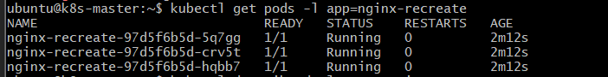

11. Verify the Strategy
Run:
kubectl describe deployment nginx-recreate
Look for:
StrategyType: Recreate
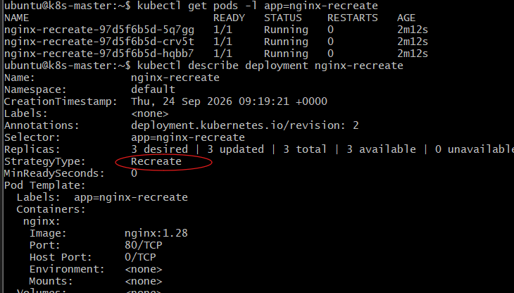

12. RollingUpdate vs Recreate
This is an important interview question.
Feature | RollingUpdate | Recreate
Old Pods | Gradually removed | All removed first
New Pods | Gradually created | Created after old Pods are removed
Downtime | Designed to avoid it | Expected during transition
Old/New versions coexist | Yes, temporarily | No
Deployment speed | Gradual | Usually simpler/faster
Typical use | Production web applications | Applications that cannot have multiple versions running

Simple example
RollingUpdate:
Old → Old → New
Old → New → New
New → New → New
Recreate:
Old → Old → Old
↓
NONE
↓
New → New → New

13. Validation Commands
Run these after the update:
kubectl get deployment nginx-recreate
kubectl get pods -l app=nginx-recreate -o wide
kubectl describe deployment nginx-recreate | grep -E "StrategyType|Image"
kubectl rollout status deployment/nginx-recreate
Expected:
deployment "nginx-recreate" successfully rolled out
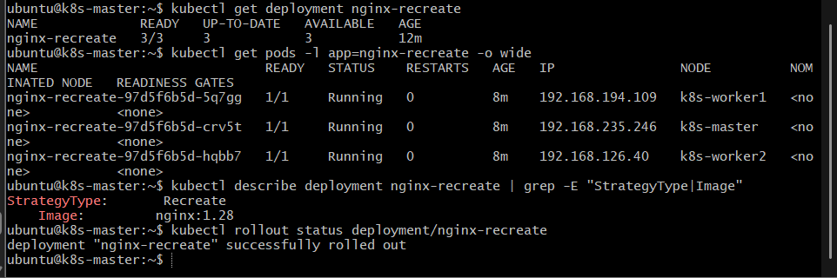

14. Expected Outcome
After completing Task 2:
- A Deployment named nginx-recreate exists.
- It has 3 replicas.
- Its strategy is Recreate.
- The image was updated from nginx:1.27 to nginx:1.28.
- Kubernetes terminated the old Pods before creating the new Pods.
- You observed a period where the Deployment had no running application Pods, demonstrating the potential downtime of the Recreate strategy.
- The final state contains 3 new nginx:1.28 Pods.

Task 3 — Update a Deployment and Roll Back to the Previous Version

1. Objective
In this task, we will:
- Use an existing Deployment.
- Update its application version.
- Observe the new ReplicaSet being created.
- Check the rollout history.
- Roll back to the previous version.
- Verify that the old application version is restored.
We will use the Task 1 Deployment:
nginx-deployment
This is useful because we already have multiple revisions from Task 1.

2. Architecture

Initial state
Deployment
nginx-deployment
|
v
ReplicaSet v1
|
+-----------+-----------+
| | |
v v v
Pod-1 Pod-2 Pod-3
nginx:1.27 nginx:1.27 nginx:1.27

After updating to nginx:1.29
Deployment
nginx-deployment
|
+-----------+-----------+
| |
v v
Old ReplicaSet New ReplicaSet
nginx:1.28 nginx:1.29
| |
Old Pods New Pods
Kubernetes gradually replaces the old Pods because this Deployment uses RollingUpdate.

After rollback
Deployment
nginx-deployment
|
v
Previous version
nginx:1.28
|
+-----------+-----------+
| | |
v v v
Pod-1 Pod-2 Pod-3
nginx:1.28 nginx:1.28 nginx:1.28

Flow explanation
- We have a working Deployment.
- We update it to a new image version.
- Kubernetes creates a new ReplicaSet.
- The new Pods replace the old Pods.
- We inspect the rollout history.
- We decide to return to the previous revision.
- kubectl rollout undo tells Kubernetes to restore the previous Deployment revision.
- Kubernetes performs another rolling update back to the previous version.

3. Implementation

Step 3.1 — Check the existing Deployment
Run:
kubectl get deployment nginx-deployment
Expected:
NAME READY UP-TO-DATE AVAILABLE
nginx-deployment 3/3 3 3

Step 3.2 — Check the current image
Run:
kubectl describe deployment nginx-deployment | grep -i image
You should currently have:
Image: nginx:1.28
This is the version we want to use as our previous version.
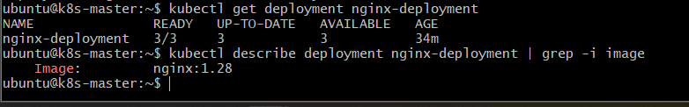

4. Check Rollout History
Run:
kubectl rollout history deployment/nginx-deployment
You should see revisions similar to:
deployment.apps/nginx-deployment
REVISION CHANGE-CAUSE
1 <none>
2 <none>
The exact revision numbers may differ.
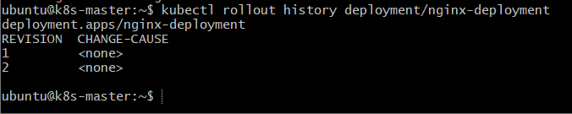
Currently, your latest revision should correspond to the nginx:1.28 configuration.

5. Update the Deployment
We will now update:
nginx:1.28
to:
nginx:1.29
Open the YAML:
nano nginx-deployment.yaml
Find:
image: nginx:1.28
Change it to:
image: nginx:1.29
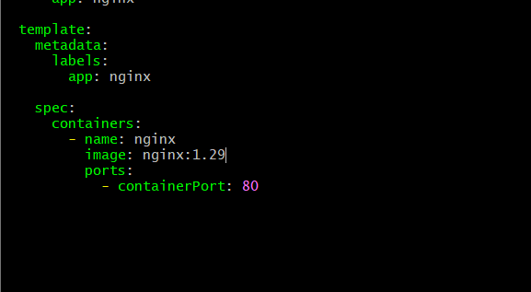
Save:
Ctrl + O
Enter
Ctrl + X

6. Apply the Update
Run:
kubectl apply -f nginx-deployment.yaml
Expected:
deployment.apps/nginx-deployment configured

7. Watch the Rollout
Run:
kubectl rollout status deployment/nginx-deployment
Expected:
deployment "nginx-deployment" successfully rolled out
You can also watch the Pods:
kubectl get pods -l app=nginx -w
You should see the old Pods being replaced by new Pods.
Stop watching:
Ctrl + C
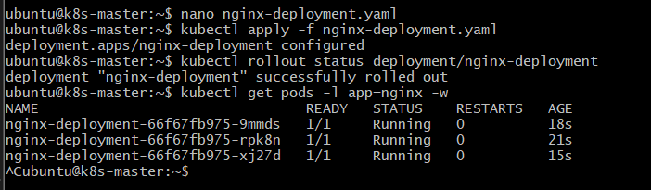

8. Verify the New Version
Run:
kubectl describe deployment nginx-deployment | grep -i image
Expected:
Image: nginx:1.29
Also:
kubectl get pods -l app=nginx
All 3 Pods should be:
Running
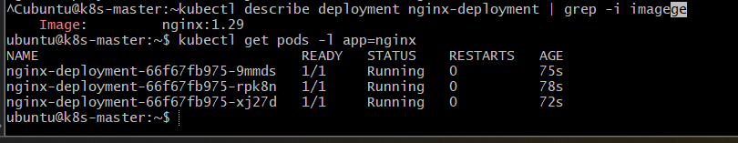

9. Check ReplicaSets
This is important because it shows how Kubernetes maintains the Deployment history.
Run:
kubectl get rs
You should see multiple ReplicaSets associated with nginx-deployment.
For example:
NAME DESIRED CURRENT READY
nginx-deployment-aaaaaaa 0 0 0
nginx-deployment-bbbbbbb 0 0 0
nginx-deployment-ccccccc 3 3 3
The old ReplicaSets remain because Kubernetes keeps Deployment revision history.
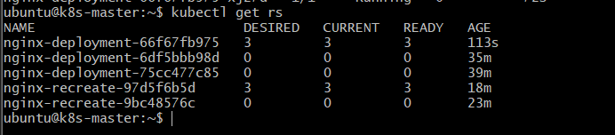

10. Check Rollout History Again
Run:
kubectl rollout history deployment/nginx-deployment
You should now have another revision:
deployment.apps/nginx-deployment
REVISION CHANGE-CAUSE
1 <none>
2 <none>
3 <none>
The newest revision represents the nginx:1.29 update.
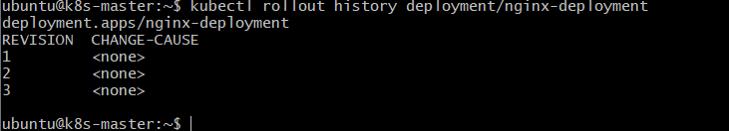

11. Roll Back to the Previous Version
Now we'll perform the actual rollback.
Run:
kubectl rollout undo deployment/nginx-deployment
Expected:
deployment.apps/nginx-deployment rolled back
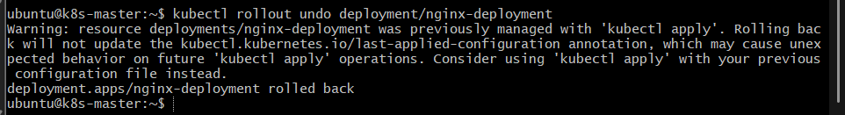
This tells Kubernetes:
Restore the Deployment to the previous revision.

12. Watch the Rollback
Run:
kubectl rollout status deployment/nginx-deployment
Expected:
deployment "nginx-deployment" successfully rolled out
You can also watch:
kubectl get pods -l app=nginx -w
You should see Kubernetes replace the nginx:1.29 Pods with Pods from the previous revision.
Stop watching with:
Ctrl + C
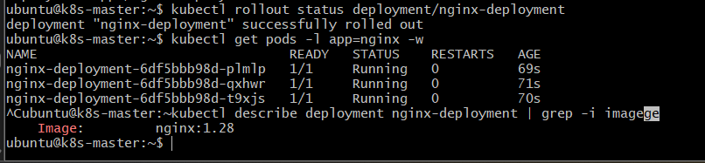

13. Verify the Rollback
Run:
kubectl describe deployment nginx-deployment | grep -i image
Expected:
Image: nginx:1.28
So we have:
nginx:1.28
↓
Update
↓
nginx:1.29
↓
Rollback
↓
nginx:1.28

14. Verify the Deployment
Run:
kubectl get deployment nginx-deployment
Expected:
NAME READY UP-TO-DATE AVAILABLE
nginx-deployment 3/3 3 3

15. Verify Rollout History
Run:
kubectl rollout history deployment/nginx-deployment
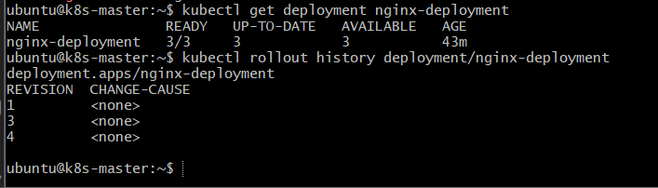
Notice something important:
Rollback does not simply delete the revision history.
Kubernetes creates a new revision representing the rollback.
Conceptually:
Revision 1
nginx:1.27
↓
Revision 2
nginx:1.28
↓
Revision 3
nginx:1.29
↓
Rollback
↓
Revision 4
nginx:1.28
So although we returned to the nginx:1.28 configuration, Kubernetes records the rollback as a new revision.

16. Important Commands to Remember

View rollout history
kubectl rollout history deployment/nginx-deployment

Update Deployment
kubectl apply -f nginx-deployment.yaml

Check rollout
kubectl rollout status deployment/nginx-deployment

Roll back to previous revision
kubectl rollout undo deployment/nginx-deployment

View ReplicaSets
kubectl get rs

17. Interview Explanation

Question: How do you roll back a Kubernetes Deployment?
Answer:
I use kubectl rollout undo deployment/<deployment-name>. Kubernetes uses the previous ReplicaSet stored in the Deployment's revision history and performs a rollout back to that version.
Example:
kubectl rollout undo deployment/nginx-deployment

Question: Does rollback delete the Deployment?
No. The Deployment remains intact. Kubernetes changes the Pod template back to the previous revision and performs another rollout.

Question: Why does Kubernetes keep old ReplicaSets?
They are used for Deployment revision history and rollback. The number of old revisions retained can be controlled using revisionHistoryLimit, which we'll practice in Task 6.

18. Expected Outcome
After completing Task 3:
- nginx-deployment was updated from nginx:1.28 → nginx:1.29.
- Kubernetes created a new ReplicaSet for the update.
- The rollout completed successfully.
- We used kubectl rollout undo to roll back.
- Kubernetes restored the previous nginx:1.28 configuration.
- The Deployment still has 3 healthy replicas.
- The rollout history contains the update and rollback revisions.

Task 4 — Add Resource Requests and Limits to a Deployment

1. Objective
In this task, we will modify our existing nginx-deployment to configure:
- CPU requests
- CPU limits
- Memory requests
- Memory limits
We will then verify that Kubernetes has applied these resource settings to the Pods.
This task also helps us understand how Kubernetes uses resource requests for scheduling and resource limits for controlling maximum resource consumption.

2. Architecture
Deployment
nginx-deployment
|
replicas: 3
|
+-----------+-----------+
| | |
v v v
Pod-1 Pod-2 Pod-3
| | |
v v v
Container Container Container
nginx nginx nginx
|
+-----------------------------+
| |
Resource Requests Resource Limits
| |
CPU: 100m CPU: 200m
Memory: 128Mi Memory: 256Mi

Flow explanation
- The Deployment specifies resource requirements for the Nginx container.
- The request tells the Kubernetes scheduler how much CPU and memory the Pod needs for scheduling.
- The limit defines the maximum CPU and memory the container is allowed to consume.
- Kubernetes uses the requests when selecting a suitable node.
- The kubelet/container runtime enforces the configured limits.

3. Important Concepts
Before implementation, understand these two terms.

Resource Request
Example:
requests:
cpu: 100m
memory: 128Mi
This means:
Kubernetes should schedule this Pod onto a node that has at least this amount of allocatable CPU and memory available for the Pod's requested resources.
100m means:
100 millicores = 0.1 CPU

Resource Limit
Example:
limits:
cpu: 200m
memory: 256Mi
This means:
The container's resource usage is constrained by these configured maximums.
For memory, exceeding the limit can result in the container being terminated with an OOMKilled status.

4. Current Deployment
We will continue using:
nginx-deployment
from Tasks 1 and 3.
First verify it:
kubectl get deployment nginx-deployment
Expected:
NAME READY UP-TO-DATE AVAILABLE
nginx-deployment 3/3 3 3

5. Check Current Resource Configuration
Run:
kubectl describe deployment nginx-deployment
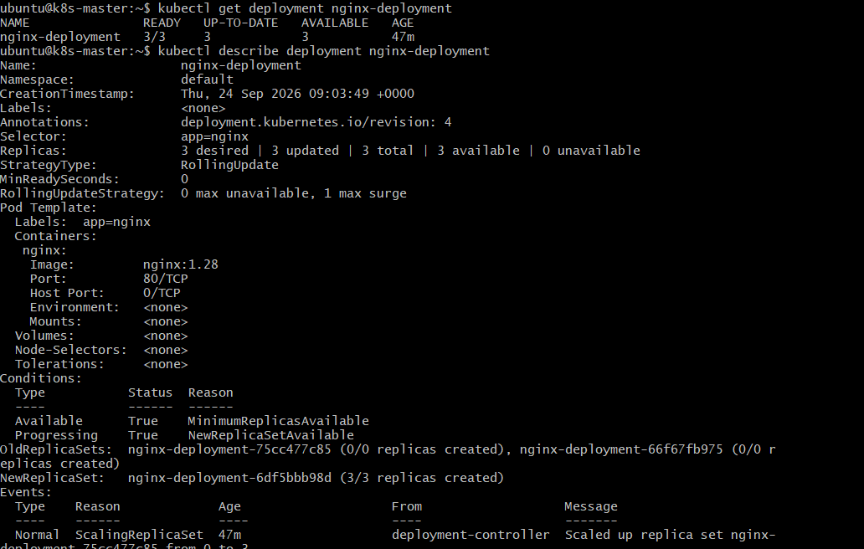
Currently, the container probably doesn't have explicit CPU and memory requests/limits.
You can also run:
kubectl get deployment nginx-deployment -o yaml
Look under:
containers:

6. Modify the Deployment YAML
Open:
nano nginx-deployment.yaml
Find the container section.
It currently looks similar to:
containers:
- name: nginx
image: nginx:1.28
ports:
- containerPort: 80
Modify it to:
containers:
- name: nginx
image: nginx:1.28
ports:
- containerPort: 80

resources:
requests:
cpu: "100m"
memory: "128Mi"

limits:
cpu: "200m"
memory: "256Mi"
So the complete YAML should look like:
apiVersion: apps/v1
kind: Deployment

metadata:
name: nginx-deployment

spec:
replicas: 3

strategy:
type: RollingUpdate

rollingUpdate:
maxSurge: 1
maxUnavailable: 0

selector:
matchLabels:
app: nginx

template:
metadata:
labels:
app: nginx

spec:
containers:
- name: nginx
image: nginx:1.28

ports:
- containerPort: 80

resources:
requests:
cpu: "100m"
memory: "128Mi"

limits:
cpu: "200m"
memory: "256Mi"
Save:
Ctrl + O
Enter
Ctrl + X
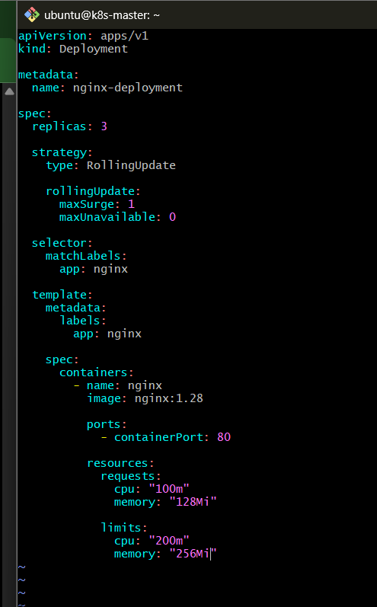

7. Understand the Configuration
We have configured:
requests:
cpu: "100m"
memory: "128Mi"
and:
limits:
cpu: "200m"
memory: "256Mi"
So for each Pod:
Resource | Request | Limit
CPU | 100m | 200m
Memory | 128Mi | 256Mi
Because we have:
replicas: 3
the total requested resources across the three Pods are approximately:
CPU:
3 × 100m = 300m

Memory:
3 × 128Mi = 384Mi
The limits across all three Pods are:
CPU:
3 × 200m = 600m

Memory:
3 × 256Mi = 768Mi
These are Pod/container resource configurations, not a guarantee that the application will actually consume the full limit.

8. Apply the Changes
Run:
kubectl apply -f nginx-deployment.yaml
Expected:
deployment.apps/nginx-deployment configured
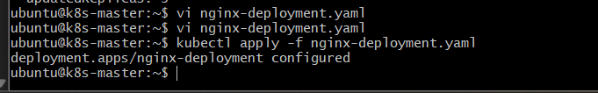
Because we changed the Pod template, Kubernetes creates a new ReplicaSet and performs a rolling update.

9. Watch the Rollout
Run:
kubectl rollout status deployment/nginx-deployment
Expected:
deployment "nginx-deployment" successfully rolled out

10. Verify the Deployment
Run:
kubectl get deployment nginx-deployment
Expected:
NAME READY UP-TO-DATE AVAILABLE
nginx-deployment 3/3 3 3

11. Verify Resource Requests and Limits
Run:
kubectl describe deployment nginx-deployment
Look for:
Limits:
cpu: 200m
memory: 256Mi
Requests:
cpu: 100m
memory: 128Mi
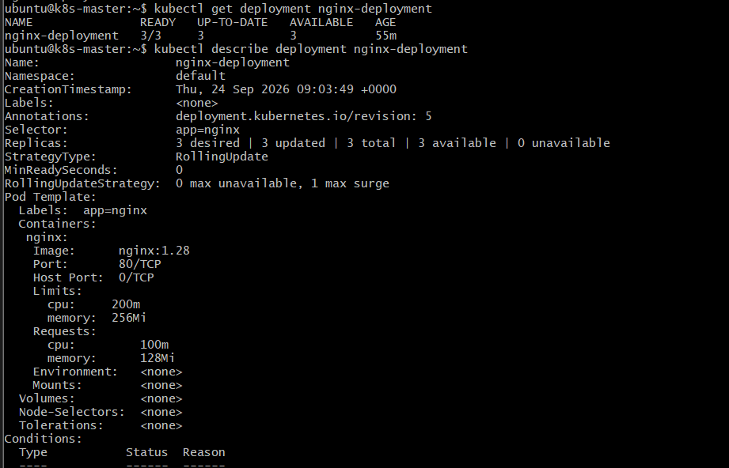
This confirms the Deployment configuration.

12. Verify at Pod Level
First get the Pods:
kubectl get pods -l app=nginx
Pick one Pod name.
For example:
nginx-deployment-xxxxxxxxxx
Then:
kubectl describe pod nginx-deployment-xxxxxxxxxx
Look for:
Limits:
cpu: 200m
memory: 256Mi
Requests:
cpu: 100m
memory: 128Mi
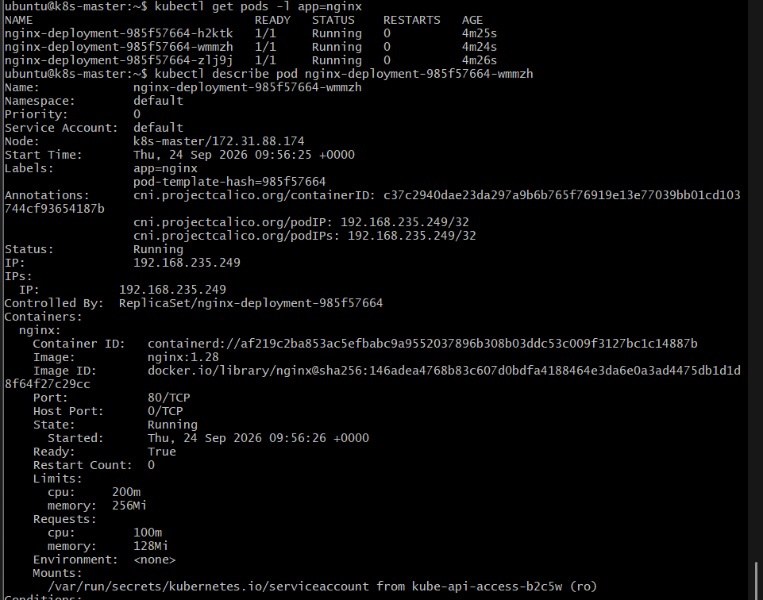
You can also check all Pods more directly:
kubectl get pods -l app=nginx -o yaml

13. Check Node Resource Information
Now let's see why requests matter for scheduling.
Run:
kubectl get nodes
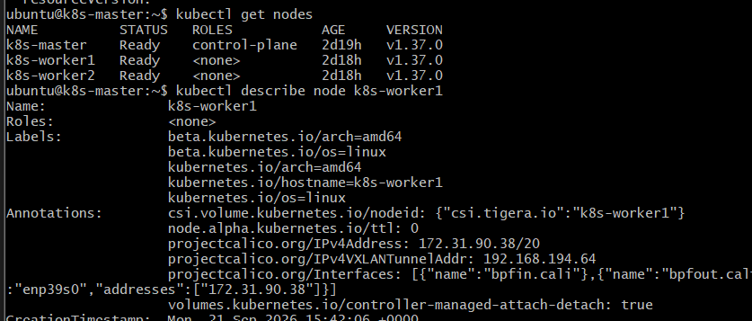
Then:
kubectl describe node k8s-worker1
Look for:
Allocatable:
and:
Allocated resources:
You'll see something similar to:
Allocated resources:
Resource Requests Limits
-------- -------- ------
cpu ... ...
memory ... ...
The exact values depend on what else is running on your cluster.
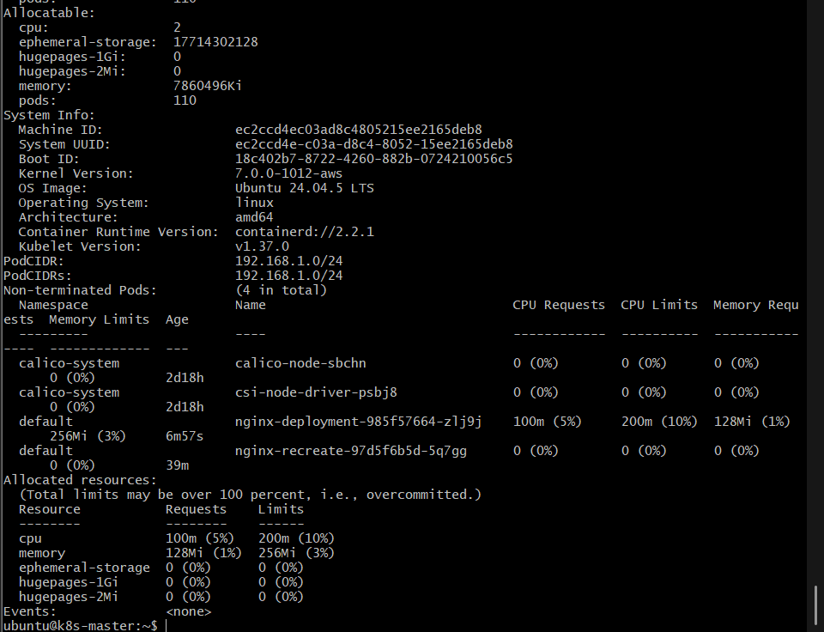

14. Important Difference: Request vs Limit

Request
CPU request = 100m
Memory request = 128Mi
The scheduler uses these values when deciding:
Which node can accommodate this Pod?
Conceptually:
Pod requests:
100m CPU
128Mi Memory

↓

Scheduler checks nodes

↓

Node has enough allocatable resources?

↓ YES

Pod can be scheduled there

Limit
CPU limit = 200m
Memory limit = 256Mi
The limit controls the maximum resource usage configured for the container.
A useful simplified way to remember it:
Request → Scheduling
Limit → Maximum allowed usage

15. Expected Architecture
Kubernetes Cluster
|
v
nginx-deployment
replicas = 3
|
+------------------+------------------+
| | |
v v v
Pod-1 Pod-2 Pod-3
| | |
v v v
nginx nginx nginx
| | |
+------+-------+ +-----+--------+ +-----+--------+
| | | | | |
Request Limit Request Limit Request Limit
CPU 100m CPU 200m CPU 100m CPU 200m CPU 100m CPU 200m
Mem 128Mi Mem 256Mi Mem 128Mi Mem 256Mi Mem 128Mi Mem 256Mi

16. Expected Outcome
After completing Task 4:
- nginx-deployment has 3 replicas.
- Each Nginx container has:
  - CPU request: 100m
  - Memory request: 128Mi
  - CPU limit: 200m
  - Memory limit: 256Mi
- Kubernetes successfully performs the Deployment update.
- All 3 Pods remain Running.
- You can see the requests and limits using kubectl describe deployment and kubectl describe pod.
- You understand that requests influence scheduling, while limits constrain resource usage.

Task 5 — Configure MaxSurge and MaxUnavailable

1. Objective
In this task, we will configure a Deployment with:
- 3 replicas
- RollingUpdate strategy
- maxSurge
- maxUnavailable
We will update the Deployment and observe how Kubernetes controls the number of Pods during the rolling update.
We will continue using our existing:
nginx-deployment

2. Architecture
We currently have:
Deployment
nginx-deployment
|
replicas: 3
|
+----------+----------+
| | |
v v v
Pod-1 Pod-2 Pod-3
nginx:1.28 nginx:1.28 nginx:1.28
During a rolling update, we configure:
maxSurge: 1
maxUnavailable: 1
The behavior is approximately:
Initial:
3 old Pods
|
v
Old Old Old

↓ Update

Create 1 new Pod
|
v
Old Old Old New
(4 total)

↓

Remove 1 old Pod
|
v
Old Old New
(3 total)

↓

Create another new Pod
|
v
Old Old New New
(4 total)

↓

Remove old Pod
|
v
Old New New
(3 total)

↓

Create final new Pod
|
v
Old New New New
(4 total)

↓

Remove final old Pod
|
v
New New New
(3 total)
The exact sequence can vary slightly based on Pod readiness and termination timing, but Kubernetes respects the configured surge/unavailable constraints.

3. Understand MaxSurge
We configure:
maxSurge: 1
maxSurge defines how many Pods above the desired replica count Kubernetes can temporarily create during an update.
Our desired count is:
replicas = 3
With:
maxSurge = 1
Kubernetes can temporarily have:
3 + 1 = 4 Pods
So:
Desired Pods = 3
Maximum during update = 4

4. Understand MaxUnavailable
We configure:
maxUnavailable: 1
This means Kubernetes can have up to 1 fewer available Pod than the desired replica count during the update.
With:
replicas = 3
maxUnavailable = 1
Kubernetes can temporarily have:
3 - 1 = 2 available Pods
So:
Desired = 3
Minimum available = 2

5. Current Deployment
First verify:
kubectl get deployment nginx-deployment
Expected:
NAME READY UP-TO-DATE AVAILABLE
nginx-deployment 3/3 3 3
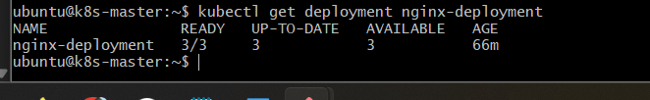

6. Modify the Deployment YAML
Open:
nano nginx-deployment.yaml
Find:
strategy:
type: RollingUpdate
Modify it to:
strategy:
type: RollingUpdate
rollingUpdate:
maxSurge: 1
maxUnavailable: 1
Your relevant section should now be:
spec:
replicas: 3

strategy:
type: RollingUpdate
rollingUpdate:
maxSurge: 1
maxUnavailable: 1
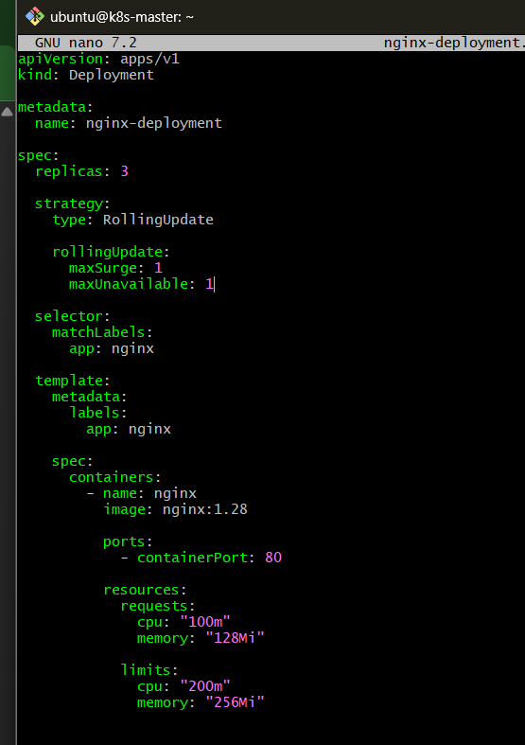
Keep the resource configuration from Task 4.
Your container should still have:
resources:
requests:
cpu: "100m"
memory: "128Mi"

limits:
cpu: "200m"
memory: "256Mi"

7. Apply the Configuration
Run:
kubectl apply -f nginx-deployment.yaml
Expected:
deployment.apps/nginx-deployment configured
Because we only changed the Deployment strategy configuration, Kubernetes may not create a new rollout immediately.
That's okay.

8. Verify MaxSurge and MaxUnavailable
Run:
kubectl describe deployment nginx-deployment
Look for:
StrategyType: RollingUpdate
RollingUpdateStrategy: 1 max unavailable, 1 max surge
This confirms the configuration.
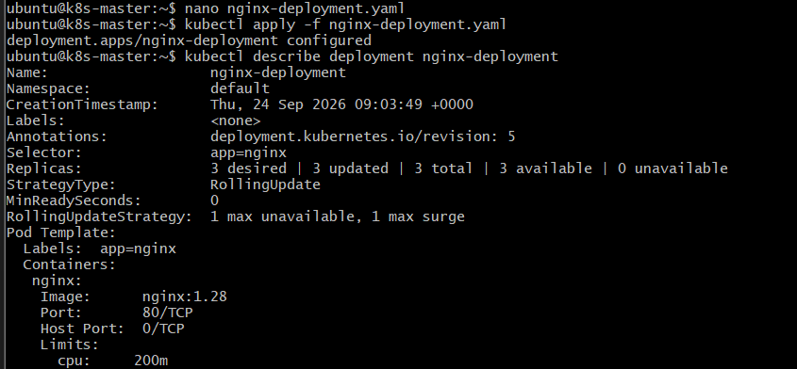

9. Create a New Version to Trigger the Rolling Update
Now we'll change the Nginx version.
Currently:
image: nginx:1.28
Change it to:
image: nginx:1.29
So:
containers:
- name: nginx
image: nginx:1.29
ports:
- containerPort: 80

resources:
requests:
cpu: "100m"
memory: "128Mi"

limits:
cpu: "200m"
memory: "256Mi"
Save the file.
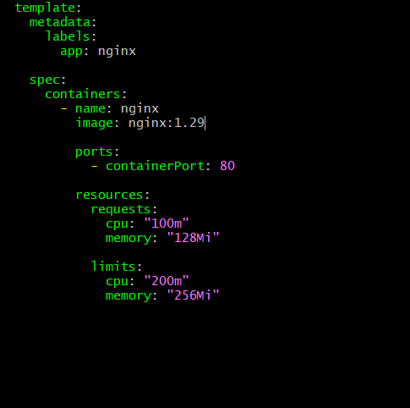

10. Watch the Rolling Update
Open one terminal and run:
kubectl get pods -l app=nginx -w
Then, from another terminal:
kubectl apply -f nginx-deployment.yaml
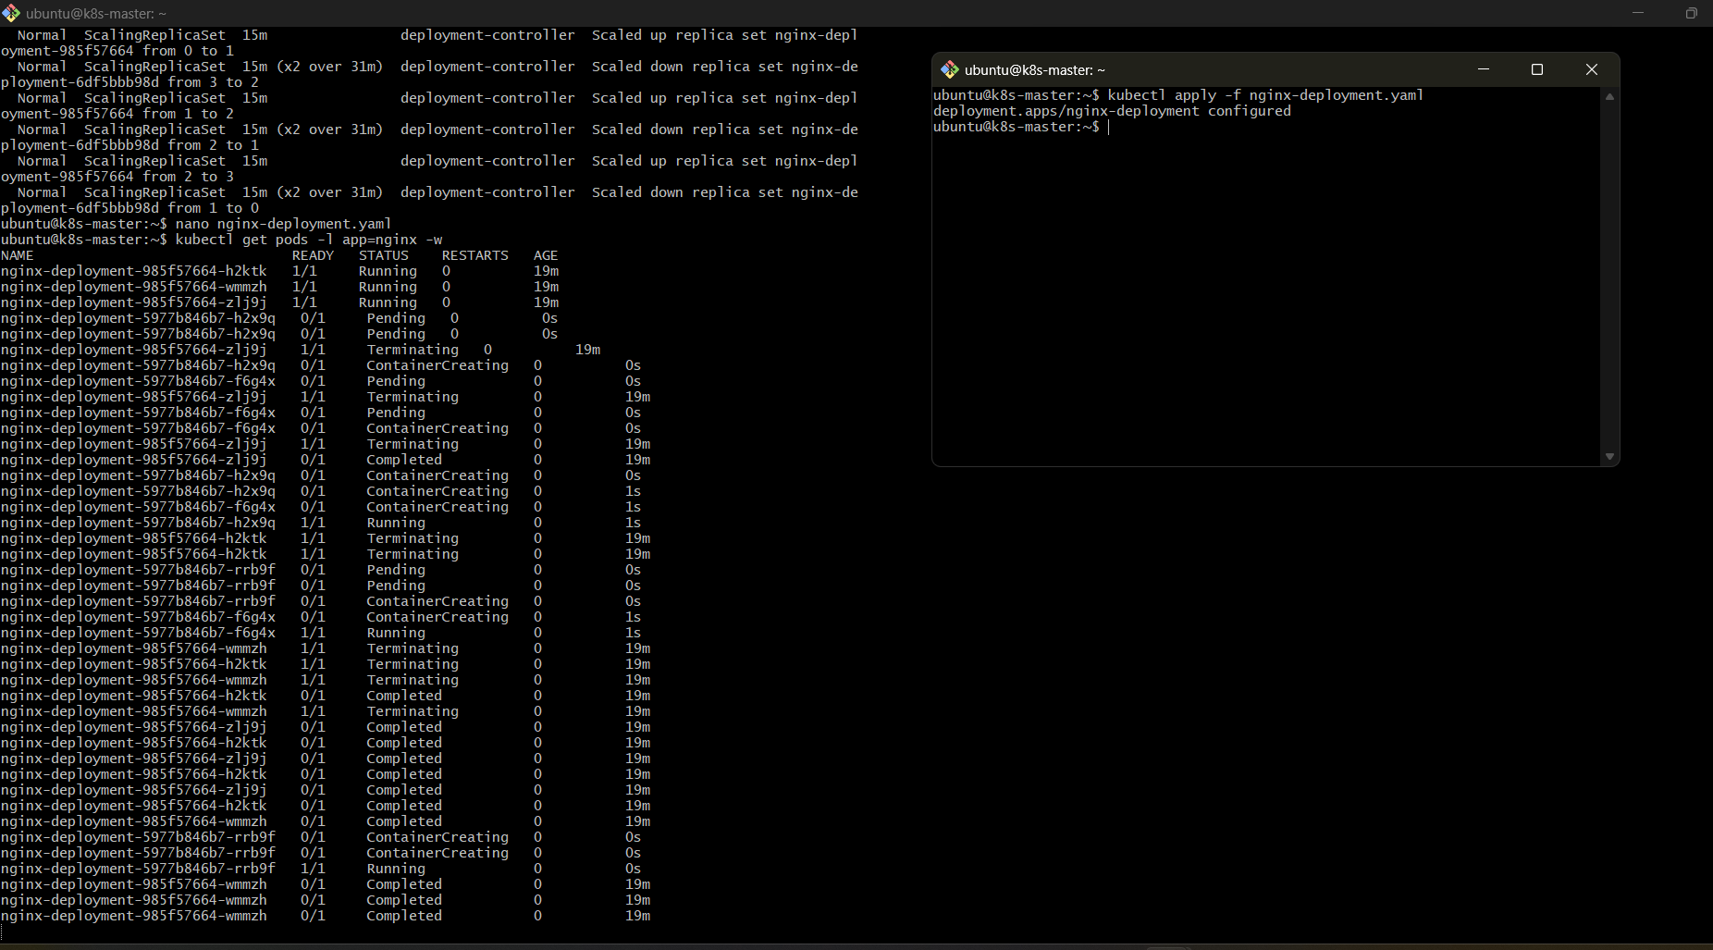
You should see old Pods being replaced by new Pods.
You may observe states such as:
Old Pods:
nginx-deployment-xxxxx
nginx-deployment-yyyyy
nginx-deployment-zzzzz
Then a new Pod appears:
Old Old Old New
At one point there can be up to:
4 Pods
because:
replicas = 3
maxSurge = 1
Eventually old Pods are removed and the final state becomes:
New New New
Stop watching:
Ctrl + C

11. Check the Deployment During the Update
You can use:
kubectl get deployment nginx-deployment
During an update you may see values change such as:
READY
3/3

UP-TO-DATE
2

AVAILABLE
3
The values change as the rollout progresses.
After completion:
NAME READY UP-TO-DATE AVAILABLE
nginx-deployment 3/3 3 3
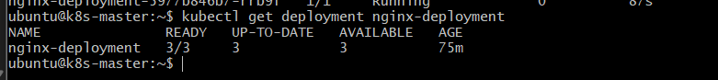

12. Check the ReplicaSets
Run:
kubectl get rs
You should see the old ReplicaSet and the new ReplicaSet.
Example:
NAME DESIRED CURRENT READY
nginx-deployment-old 0 0 0
nginx-deployment-new 3 3 3
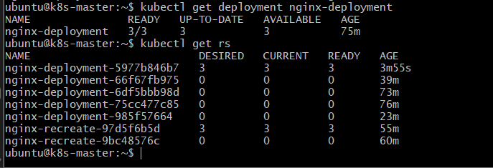
During the rollout, both ReplicaSets temporarily participate.
Conceptually:
Deployment
|
+-------------------+
| |
v v
Old ReplicaSet New ReplicaSet
| |
Old Pods New Pods

13. Check the New Image
Run:
kubectl describe deployment nginx-deployment | grep -i image
Expected:
Image: nginx:1.29

14. Check the Rollout
Run:
kubectl rollout status deployment/nginx-deployment
Expected:
deployment "nginx-deployment" successfully rolled out
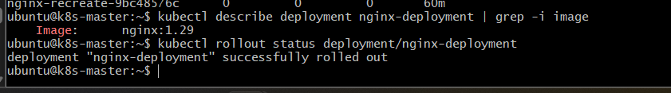

15. Important Difference Between Task 1 and Task 5
In Task 1 we used:
maxSurge: 1
maxUnavailable: 0
Now we are using:
maxSurge: 1
maxUnavailable: 1

Task 1
Desired = 3

Maximum Pods:
3 + 1 = 4

Minimum available:
3 - 0 = 3
So Kubernetes tries to maintain all 3 available Pods.

Task 5
Desired = 3

Maximum Pods:
3 + 1 = 4

Minimum available:
3 - 1 = 2
So Kubernetes is allowed to temporarily have only 2 available Pods during the rollout.

16. Interview Example

Question
What is maxSurge?
Answer:
maxSurge controls how many additional Pods can be created above the desired replica count during a rolling update.
Example:
replicas: 3
maxSurge: 1
Maximum Pods during the update:
3 + 1 = 4

Question
What is maxUnavailable?
Answer:
maxUnavailable controls how many Pods can be unavailable during a rolling update compared with the desired replica count.
Example:
replicas: 3
maxUnavailable: 1
Minimum available Pods:
3 - 1 = 2

17. Percentage Values
Both settings can also use percentages.
For example:
rollingUpdate:
maxSurge: 25%
maxUnavailable: 25%
If:
replicas = 4
then 25% is approximately:
4 × 25% = 1
So Kubernetes can have approximately:
Maximum = 5 Pods
Minimum available = 3 Pods
For this lab, we're using simple integer values because they're easier to observe.

18. Final Architecture
Deployment
nginx-deployment
|
replicas: 3
|
RollingUpdate Strategy
|
+------------+------------+
| |
maxSurge: 1 maxUnavailable: 1
| |
v v
Maximum 4 Pods Minimum 2 Available
temporarily Pods during
during update update

19. Expected Outcome
After completing Task 5:
- nginx-deployment uses RollingUpdate.
- replicas remains 3.
- maxSurge is configured to 1.
- maxUnavailable is configured to 1.
- We triggered an application update.
- Kubernetes used the configured surge/unavailable limits during the rollout.
- The final Deployment has 3 healthy Pods running nginx:1.29.

Task 6 — Configure a Custom Revision History Limit

1. Objective
In this task, we will configure a Kubernetes Deployment with a custom:
revisionHistoryLimit
We will:
- Configure how many old ReplicaSets Kubernetes should retain.
- Perform multiple Deployment updates.
- Observe old ReplicaSets.
- Verify that Kubernetes removes revisions beyond the configured limit.
We will continue using:
nginx-deployment

2. Architecture
Normally, Kubernetes keeps old ReplicaSets for Deployment rollback.
Deployment
nginx-deployment
|
+---------------+---------------+
| | |
v v v
ReplicaSet ReplicaSet ReplicaSet
Revision 1 Revision 2 Revision 3
| | |
Old Pods Old Pods Current Pods
We will configure:
revisionHistoryLimit: 3
Meaning Kubernetes should retain 3 old revisions of the Deployment's ReplicaSets.
Conceptually:
Revision 1 ─┐
Revision 2 │
Revision 3 ├── Retained
Revision 4 ─┘

Revision 5 → when enough newer revisions exist,
older ReplicaSets can be cleaned up.

Flow explanation
- A Deployment creates a ReplicaSet.
- When the Pod template changes, a new ReplicaSet is created.
- The previous ReplicaSet is retained for rollback.
- revisionHistoryLimit controls how many old ReplicaSets Kubernetes retains.
- When the number of old revisions exceeds the configured limit, Kubernetes cleans up the oldest ones.
Important: revisionHistoryLimit is about old ReplicaSets, not the number of Pods running.

3. Current Deployment
Check the current Deployment:
kubectl get deployment nginx-deployment
Expected:
NAME READY UP-TO-DATE AVAILABLE
nginx-deployment 3/3 3 3

4. Check Current ReplicaSets
Run:
kubectl get rs
You should see multiple ReplicaSets because we've performed several updates in Tasks 1–5.
For example:
NAME DESIRED CURRENT READY
nginx-deployment-aaaaaaa 0 0 0
nginx-deployment-bbbbbbb 0 0 0
nginx-deployment-ccccccc 3 3 3
Your names will be different.
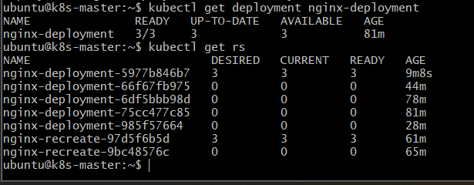

5. Check Current Revision History
Run:
kubectl rollout history deployment/nginx-deployment
You may see several revisions:
deployment.apps/nginx-deployment
REVISION CHANGE-CAUSE
1 <none>
2 <none>
3 <none>
4 <none>
5 <none>
The exact number depends on the changes you've made.
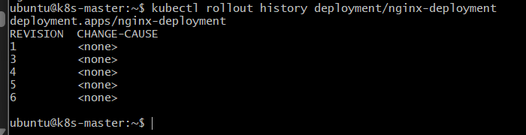

6. Configure revisionHistoryLimit
Open the Deployment YAML:
nano nginx-deployment.yaml
Under:
spec:
add:
revisionHistoryLimit: 3
For example:
spec:
replicas: 3

revisionHistoryLimit: 3

strategy:
type: RollingUpdate
rollingUpdate:
maxSurge: 1
maxUnavailable: 1
Your Deployment structure should now look like:
apiVersion: apps/v1
kind: Deployment

metadata:
name: nginx-deployment

spec:
replicas: 3

revisionHistoryLimit: 3

strategy:
type: RollingUpdate
rollingUpdate:
maxSurge: 1
maxUnavailable: 1

selector:
matchLabels:
app: nginx

template:
metadata:
labels:
app: nginx

spec:
containers:
- name: nginx
image: nginx:1.29
ports:
- containerPort: 80

resources:
requests:
cpu: "100m"
memory: "128Mi"

limits:
cpu: "200m"
memory: "256Mi"
Save:
Ctrl + O
Enter
Ctrl + X
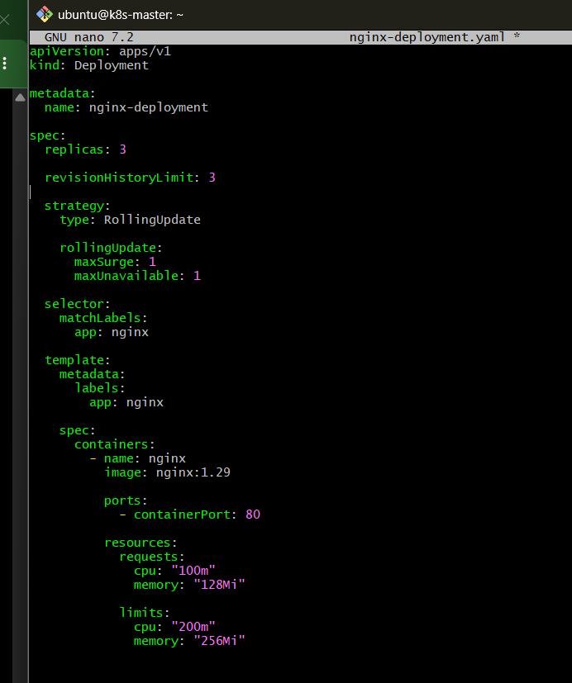

7. Apply the Configuration
Run:
kubectl apply -f nginx-deployment.yaml
Expected:
deployment.apps/nginx-deployment configured

8. Verify the Configuration
Run:
kubectl get deployment nginx-deployment -o yaml
Find:
revisionHistoryLimit: 3
Or use:
kubectl describe deployment nginx-deployment
You should see:
Revision History Limit: 3
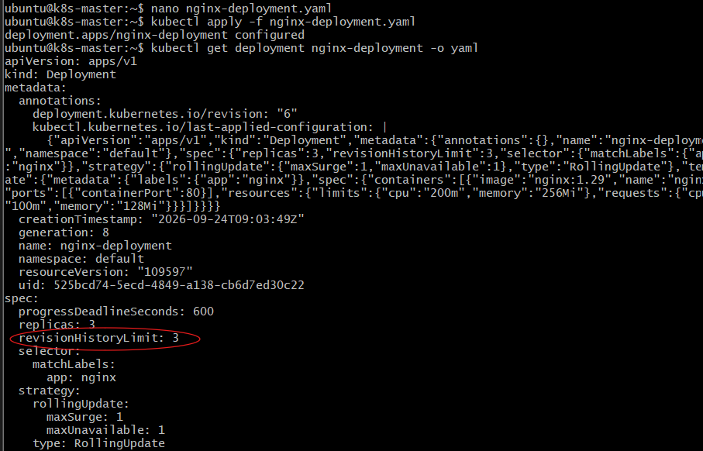
Depending on your Kubernetes output formatting, the field may be easier to verify using:
kubectl get deployment nginx-deployment -o jsonpath='{.spec.revisionHistoryLimit}'
Expected:
3

9. Important Point
Simply changing:
revisionHistoryLimit: 3
doesn't necessarily create a new application revision.
A new Deployment revision is normally created when the Pod template changes.
Therefore, we need to perform some image updates to demonstrate the behavior.

10. Create Revision 1
Our current version is:
nginx:1.29
Change it to:
nginx:1.30
In nginx-deployment.yaml:
image: nginx:1.30
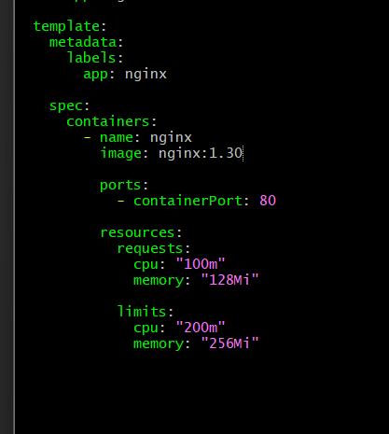
Apply:
kubectl apply -f nginx-deployment.yaml
Check:
kubectl rollout status deployment/nginx-deployment
Expected:
deployment "nginx-deployment" successfully rolled out
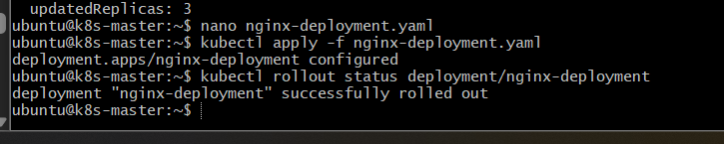

11. Create Another Revision
Change:
nginx:1.30
to:
nginx:1.31
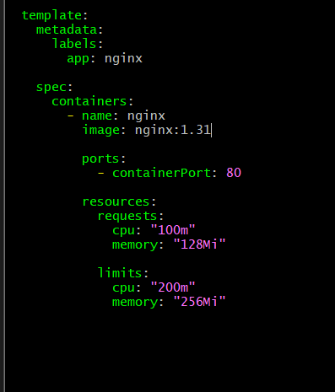
Apply:
kubectl apply -f nginx-deployment.yaml
Then:
kubectl rollout status deployment/nginx-deployment
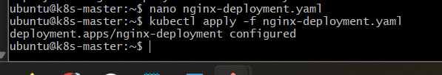

12. Create Another Revision
Change:
nginx:1.31
to:
nginx:1.32
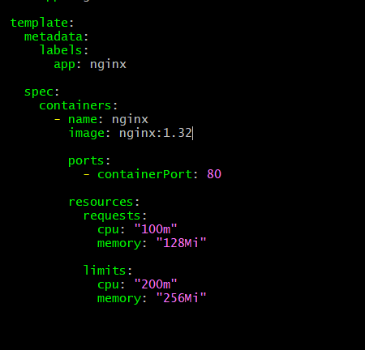
Apply:
kubectl apply -f nginx-deployment.yaml
Then:
kubectl rollout status deployment/nginx-deployment
At this point we have performed several updates.
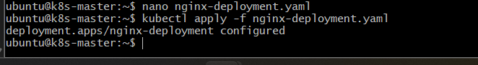

13. Check ReplicaSets
Run:
kubectl get rs
You will see several ReplicaSets.
For example:
NAME DESIRED CURRENT READY
nginx-deployment-aaaaaaa 0 0 0
nginx-deployment-bbbbbbb 0 0 0
nginx-deployment-ccccccc 0 0 0
nginx-deployment-dddddddd 3 3 3
The newest ReplicaSet has:
DESIRED = 3
The old ReplicaSets have:
DESIRED = 0
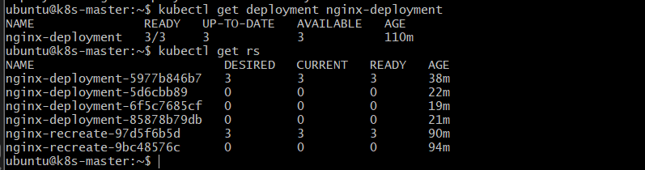

14. Check Revision History
Run:
kubectl rollout history deployment/nginx-deployment
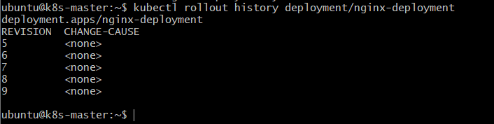
Kubernetes may show the current revision and retained historical revisions.
The important concept is:
revisionHistoryLimit: 3
means Kubernetes keeps up to 3 old ReplicaSets for this Deployment, in addition to the currently active ReplicaSet.
So don't interpret the setting as:
Total revisions = 3
It is better to think:
Current ReplicaSet
+
Up to 3 old ReplicaSets

15. Verify the Current Image
Run:
kubectl describe deployment nginx-deployment | grep -i image
Expected:
Image: nginx:1.32
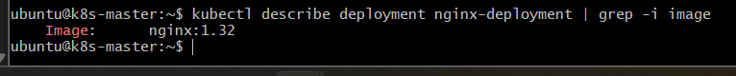
Also:
kubectl get pods -l app=nginx
Expected:
3 Pods
3/3 Running

16. Understand Why Revision History Matters
Suppose we have:
Revision 10 → nginx:1.28
Revision 11 → nginx:1.29
Revision 12 → nginx:1.30
Revision 13 → nginx:1.31
Revision 14 → nginx:1.32
If we keep only a limited number of old ReplicaSets, Kubernetes eventually removes the oldest unused ReplicaSets.
This reduces unnecessary objects in the cluster.
But there is an important tradeoff:
Higher revisionHistoryLimit
↓
More rollback history
↓
More old ReplicaSets retained

Lower revisionHistoryLimit
↓
Less historical data
↓
Less cluster object accumulation

17. Interview Question

What is revisionHistoryLimit?
Answer:
revisionHistoryLimit specifies the number of old ReplicaSets that a Deployment should retain for rollback purposes. It helps control how much historical Deployment information remains in the cluster.
Example:
revisionHistoryLimit: 3
means:
Keep up to 3 old ReplicaSets for this Deployment.

18. Important Difference
Don't confuse:
replicas: 3
with:
revisionHistoryLimit: 3

replicas
Controls the number of running Pods:
replicas: 3
↓
3 Pods

revisionHistoryLimit
Controls the number of old ReplicaSets retained:
revisionHistoryLimit: 3
↓
Up to 3 old ReplicaSets retained

19. Final Architecture
Deployment
nginx-deployment
|
revisionHistoryLimit: 3
|
+--------------+--------------+
| | |
v v v
Old RS 1 Old RS 2 Old RS 3
Revision Revision Revision
| | |
+--------------+--------------+
|
v
Current RS
|
3 Pods
|
nginx:1.32
As newer revisions are created:
Oldest ReplicaSet
↓
Eventually cleaned up
↓
Newer historical ReplicaSets retained

20. Expected Outcome
After completing Task 6:
- nginx-deployment has:
replicas: 3
- revisionHistoryLimit is:
3
- We performed multiple Deployment updates.
- New ReplicaSets were created for the updates.
- Old ReplicaSets are retained according to the revision history configuration.
- The current application version is:
nginx:1.32
- You understand the difference between running replicas and revision history.

Task 7 — Pause and Resume a Deployment

Objective
Pause an ongoing Deployment rollout, make a configuration/image change while it is paused, then resume the Deployment and verify that the new Pods are created successfully.

Implementation Steps

Step 7.1 — Make sure the Deployment is healthy
Run:
kubectl get deployment nginx-deployment
Expected:
NAME READY UP-TO-DATE AVAILABLE
nginx-deployment 3/3 3 3
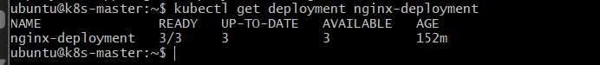
Then:
kubectl get pods -l app=nginx
All 3 Pods should be:
1/1 Running
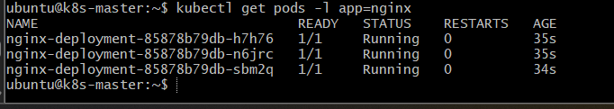

Step 7.2 — Verify the current image
kubectl describe deployment nginx-deployment | grep -i image
Expected:
Image: nginx:1.31

Step 7.3 — Pause the Deployment
Run:
kubectl rollout pause deployment/nginx-deployment
You should get:
deployment.apps/nginx-deployment paused

Step 7.4 — Change the image while the Deployment is paused
We'll change:
nginx:1.31
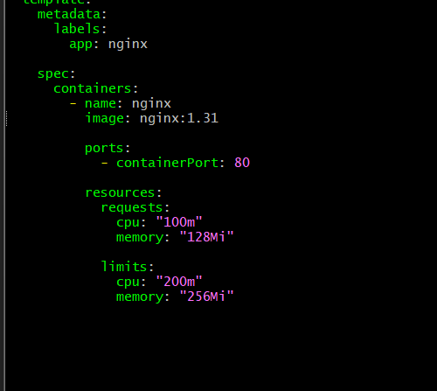
to:
nginx:1.30
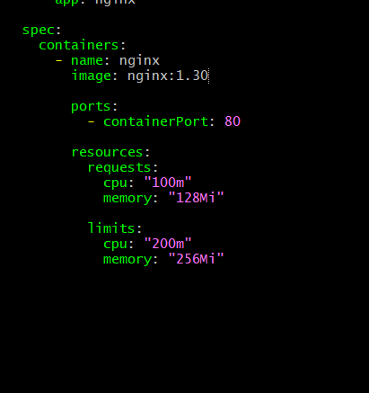
Edit your Deployment YAML:
nano nginx-deployment.yaml
Find:
image: nginx:1.31
Change it to:
image: nginx:1.30
Save:
Ctrl + O → Enter → Ctrl + X

Step 7.5 — Apply the change while paused
kubectl apply -f nginx-deployment.yaml
Then check:
kubectl get pods -l app=nginx
The important point is that the rollout should not proceed while the Deployment is paused.
The existing Pods should continue running.
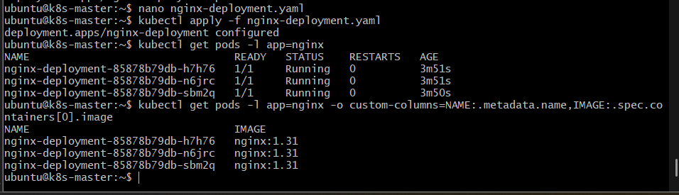

Step 7.6 — Resume the Deployment
Now run:
kubectl rollout resume deployment/nginx-deployment
Expected:
deployment.apps/nginx-deployment resumed

Step 7.7 — Monitor the rollout
kubectl rollout status deployment/nginx-deployment
Wait for:
deployment "nginx-deployment" successfully rolled out
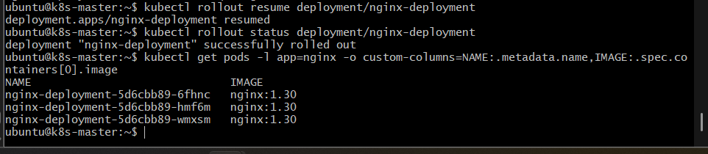

Step 7.8 — Verify the Pods
kubectl get pods -l app=nginx -o wide
All 3 Pods should eventually be:
1/1 Running

Step 7.9 — Verify the image
kubectl get pods -l app=nginx -o custom-columns=NAME:.metadata.name,IMAGE:.spec.containers[0].image
Expected:
NAME IMAGE
nginx-deployment-xxxxx-xxxxx nginx:1.30
nginx-deployment-xxxxx-xxxxx nginx:1.30
nginx-deployment-xxxxx-xxxxx nginx:1.30
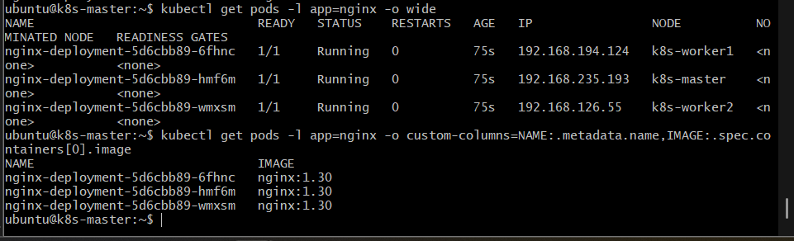
Finally:
kubectl get deployment nginx-deployment
Expected:
READY UP-TO-DATE AVAILABLE
3/3 3 3
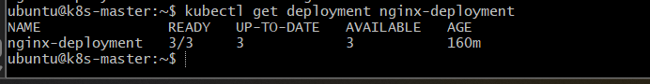

Task 8 — Pod Resource Requests and Scheduler Placement

Objective
Create a Pod with CPU and memory resource requests and observe how the Kubernetes scheduler assigns the Pod to a suitable worker node.

Implementation Steps

Step 8.1 — Create the YAML file
nano scheduler-resource-pod.yaml
Add:
apiVersion: v1
kind: Pod
metadata:
name: scheduler-resource-pod
spec:
containers:
- name: nginx
image: nginx:1.30
resources:
requests:
cpu: "500m"
memory: "256Mi"
limits:
cpu: "1"
memory: "512Mi"
Save:
Ctrl + O → Enter → Ctrl + X
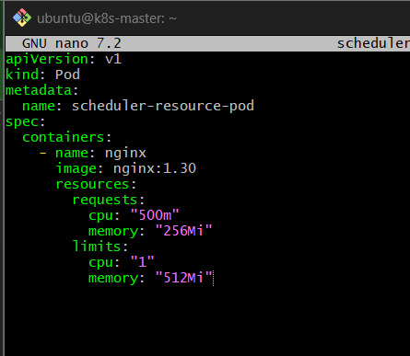

Step 8.2 — Create the Pod
kubectl apply -f scheduler-resource-pod.yaml
Expected:
pod/scheduler-resource-pod created

Step 8.3 — Check the Pod
kubectl get pod scheduler-resource-pod
Expected:
NAME READY STATUS RESTARTS AGE
scheduler-resource-pod 1/1 Running 0 ...
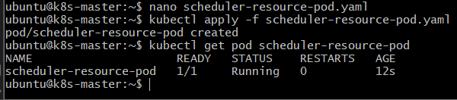

Step 8.4 — Check which node the scheduler selected
kubectl get pod scheduler-resource-pod -o wide
Look at the NODE column.
For example:
NAME READY STATUS IP NODE
scheduler-resource-pod 1/1 Running 192.168.x.x k8s-worker1
The node may be k8s-worker1 or k8s-worker2, depending on available resources.
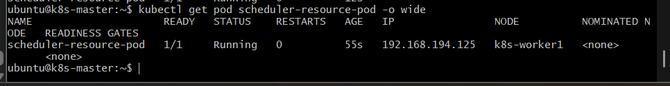

Step 8.5 — Verify the resource requests
kubectl describe pod scheduler-resource-pod
Look for:
Requests:
cpu: 500m
memory: 256Mi

Limits:
cpu: 1
memory: 512Mi

